Overview Security Auditing:
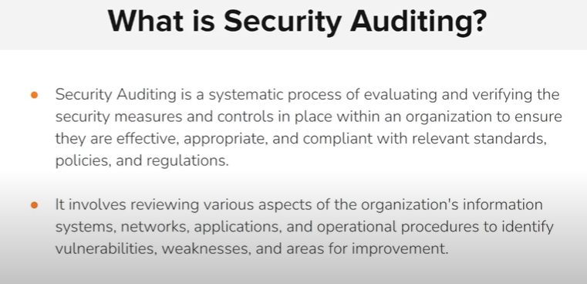

In security auditing, the goal is to check and verify whether:
- ✅ Weaknesses & vulnerabilities are identified and documented.
- ✅ Security rules, standards, and policies (like ISO 27001, NIST, GDPR, PCI-DSS, company policies) are being properly followed.
- ✅ Systems, patches, and configurations are up to date and compliant.
- ✅ Processes & controls (like access control, monitoring, backups) are implemented correctly.
- ✅ Evidence is collected to prove compliance.
So, yes — in a proper security audit, everything is reviewed to ensure that:
- Weaknesses and vulnerabilities are checked,
- Rules and standards are followed,
- And systems are current and up to date.

Importance of security auditing:
- Identifies vulnerabilities and weakness
- Ensure compliance.(GDPR ,HIPAA ,PCI DSS ,ISO 27001)
- Enhancing the risk management
- Improving the security policies and procedures
- Supporting business objectives
- Continuous improvement

NOTE:
Effective risk management is based on the audit findings.
Compliance
- Means following the rules.
- It is the act of obeying laws, regulations, or standards.
👉 Example: A company installs security patches regularly to stay compliant with security policies.

🔹 Regulatory
- Means rules made by governments or official authorities that are mandatory (legal).
- Organizations must follow them, otherwise they face penalties or legal action.
👉 Example: GDPR (Europe), HIPAA (USA healthcare), PCI-DSS (payment industry).

🔹 Standards
- Agreed best practices, usually created by industry groups or international organizations.
- Not always mandatory, but often adopted to improve security or prove compliance.
👉 Example: ISO 27001 (information security standard), NIST Cybersecurity Framework.

